UVUE Model “U4” Owners Supplement

U4 Overview

The U4 is a modern modular style dashcam recording system. It comprises of a main unit, (the so called “black box”) and two satellite Sony mini cameras. This system is designed for owners how would prefer a more stealthy product instead of the traditional larger cameras.

The U4 can be accessed by the “UVUE” smart phone app as well as using either a PC or Mac computer. The phone app is generally used to change settings or download video while the computer software will give access to far more sophisticated features.

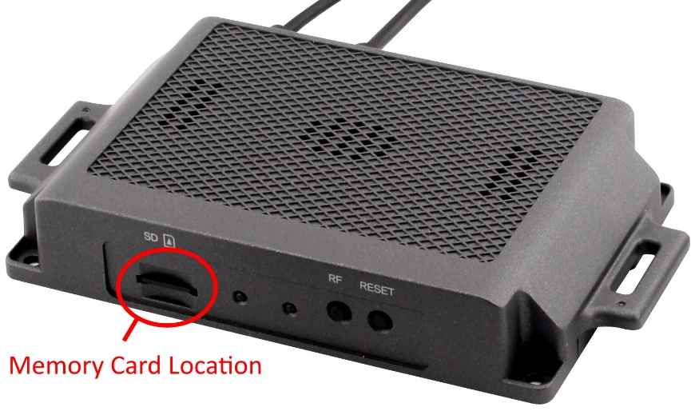

The main unit is hidden within the vehicle and a convenient sticker is located in your glove box detailing your memory cards location.

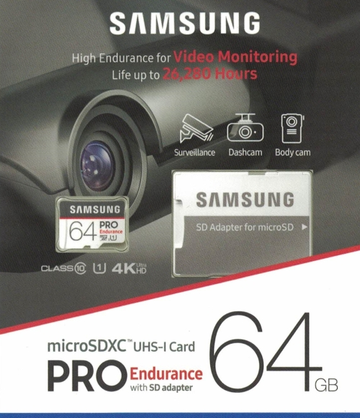

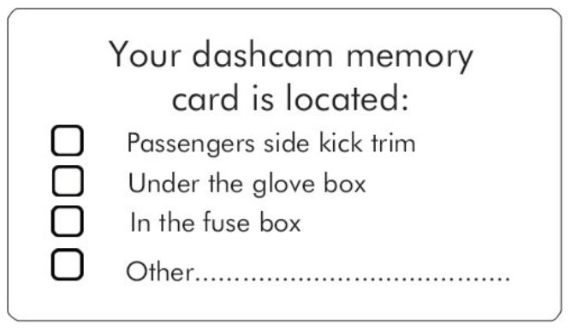The supplied memory card is a 64g Samsung Pro Endurance or Sandisk Endurance, the best on the market and should last three to five years. These are available at Office Works.

Should you require additional information please contact Rod McLaren on 0418374465.